Task 2: Basic Wireshark Traffic Capture & Analysis
2nd Year Cybersecurity Track — Intermediate Cyber Security

1. What I Did
I installed Wireshark (with the bundled Npcap driver) on my Windows machine and used it to capture live traffic on my own Wi-Fi network interface — traffic generated only by my own device, as required. During the capture window I deliberately generated a mix of activity to produce a variety of protocols to analyze:
- Browsed HTTPS sites (e.g. GitHub, Google services) in my browser, generating TLS/QUIC traffic.
- Ran nslookup and general browsing, which triggered DNS queries and responses for domains such as collector.github.com, api.github.com, and clients4.google.com.
- Let normal background activity occur, which generated TCP handshakes (SYN/SYN-ACK/ACK) and ARP requests/replies as my device resolved local network addresses.
After stopping the capture, I used Wireshark's display filter bar to isolate each protocol individually (dns, tls, tcp.flags.syn==1, arp) and inspected representative packets by expanding their protocol layers in the packet detail pane.

2. Protocols Identified

2.1 DNS (Domain Name System)
Filtering on "dns" isolated the name-resolution traffic. I could see standard queries (e.g. AAAA/A record queries for collector.github.com, api.github.com, and clients4.google.com) immediately followed by their standard query responses, which included resolved IP addresses and CNAME records. DNS here was carried over UDP port 53.
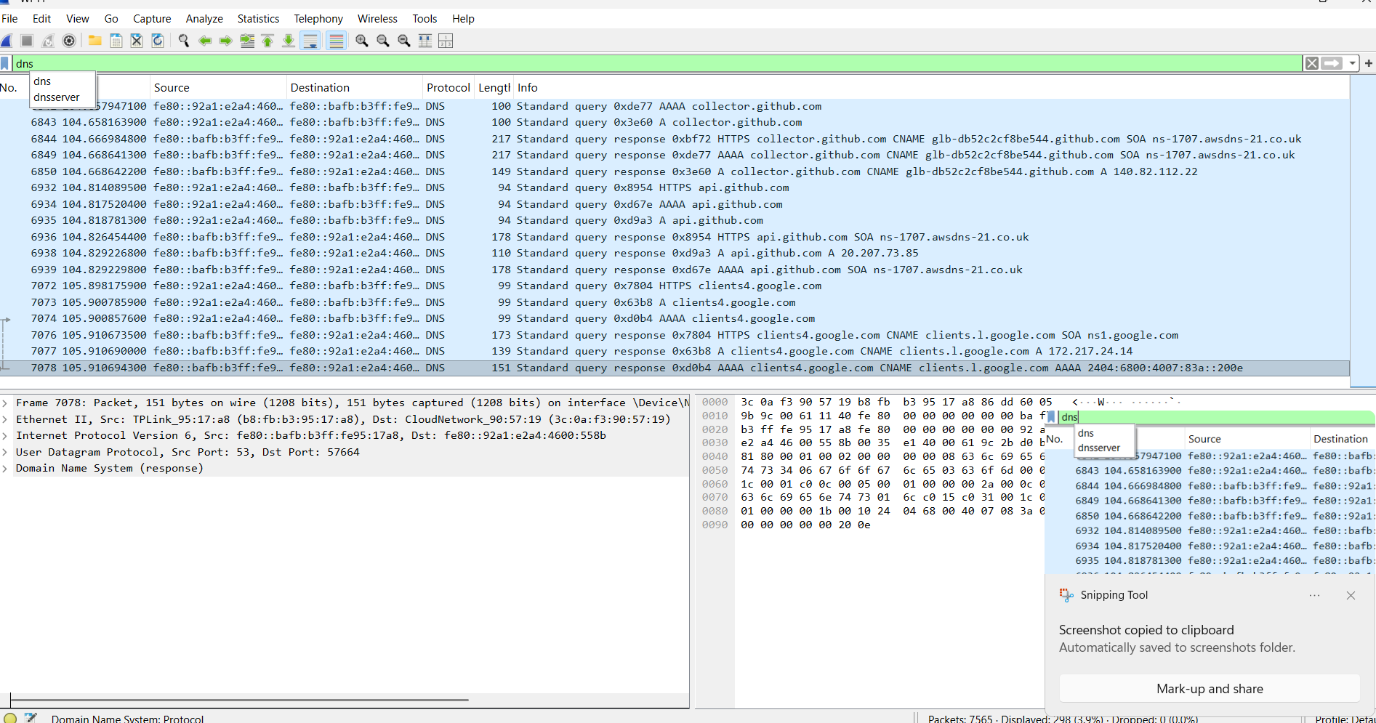
Figure 1 — DNS queries and responses filtered in Wireshark (filter: dns)

2.2 TLS / QUIC (Encrypted Application Traffic)
Filtering on "tls" showed the encrypted HTTPS traffic between my machine (192.168.0.3) and remote servers such as 140.82.112.22 (GitHub) over TCP port 443, using TLS 1.2 and TLS 1.3. Alongside this, I also noticed QUIC packets in the capture — QUIC is the newer UDP-based transport that some Google services use instead of traditional TCP+TLS, visible here as "Initial" packets with CRYPTO and PING frames. All of the payload in both cases showed only as "Application Data" — the actual content is encrypted and unreadable to anyone capturing the traffic.
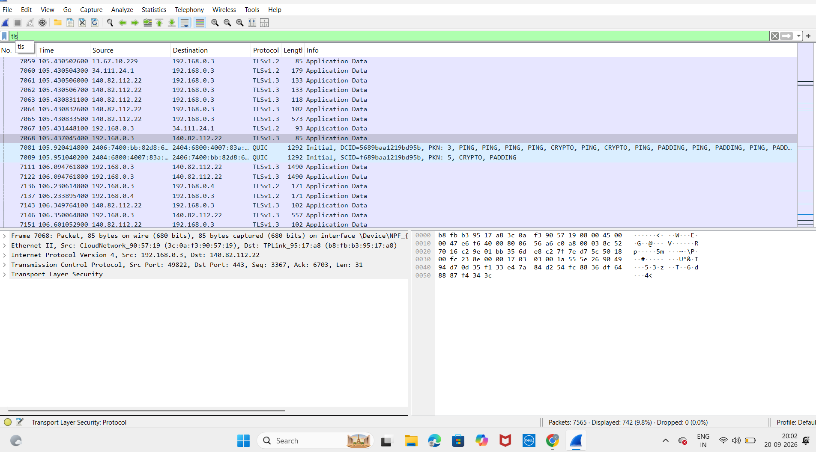
Figure 2 — TLS/QUIC encrypted application traffic (filter: tls)

2.3 TCP Handshake (SYN)
Filtering on "tcp.flags.syn==1" isolated just the SYN and SYN-ACK packets that start every TCP connection. Each new connection to a server (e.g. port 443 for HTTPS) begins with my device sending a SYN packet, the server replying with SYN, ACK, and (though not shown by this filter) my device completing the handshake with a final ACK. This confirmed multiple separate TCP sessions being opened during ordinary browsing.
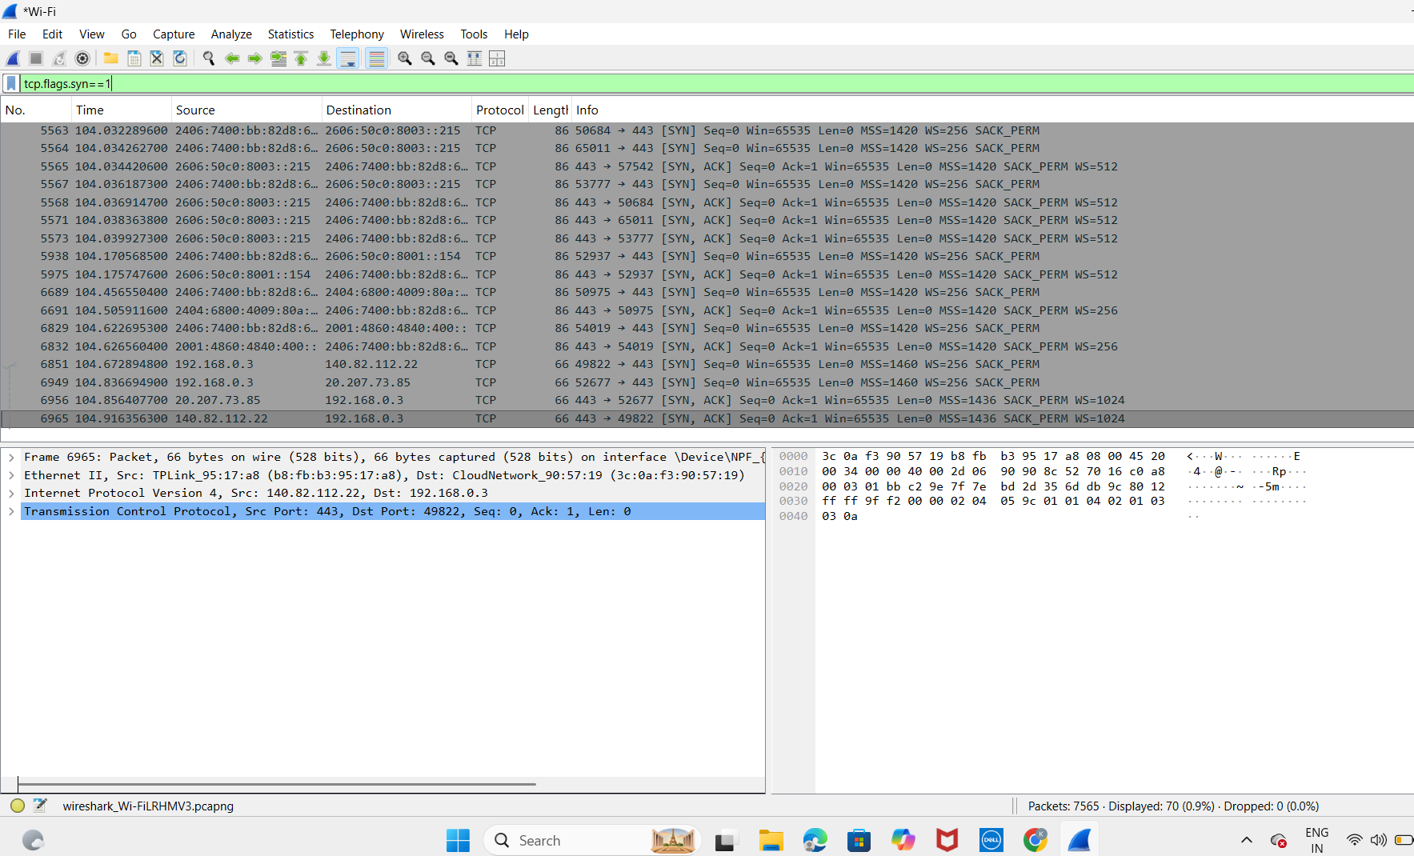
Figure 3 — TCP three-way handshake SYN/SYN-ACK packets (filter: tcp.flags.syn==1)

2.4 ARP (Address Resolution Protocol)
Filtering on "arp" showed my device (TPLink_95:17:a8) asking "Who has 192.168.0.3? Tell 192.168.0.1" and the corresponding reply "192.168.0.3 is at 3c:0a:f3:90:57:19". This is the local network resolving IP addresses to MAC addresses — it happens automatically and only ever within the local network segment, never over the internet.
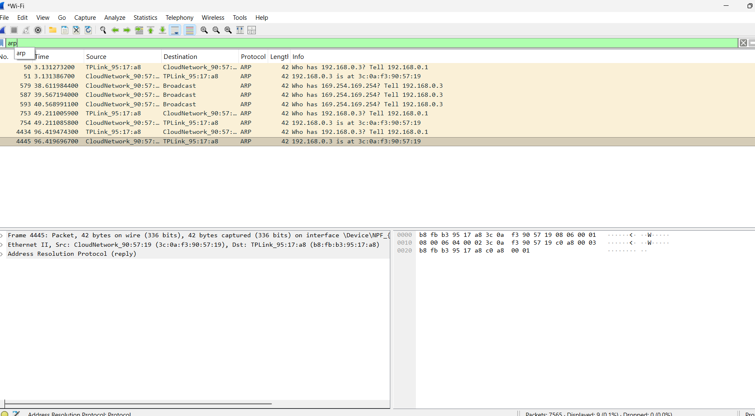
Figure 4 — ARP request/reply resolving a local IP to a MAC address (filter: arp)

3. Packet-by-Packet Walkthrough: One DNS Exchange
I chose a DNS lookup as my detailed exchange because it is short, human-readable, and clearly shows the query/response pattern common to many protocols.

3.1 The Query
Packet No. 6842 is a DNS standard query. Expanding the layers in the packet detail pane shows:
- Ethernet II — the source and destination MAC addresses on the local link.
- Internet Protocol Version 6 — source fe80::92a1:e2a4:4600:558b, destination fe80::bafb:b3ff:fe95:17a8 (link-local IPv6 addresses, since this exchange happened over IPv6 on my LAN).
- User Datagram Protocol — source port 54607, destination port 53 (the standard DNS port).
- Domain Name System (query) — Transaction ID 0xde77, Flags 0x0100 (standard query), 1 question, and a field "[Response In: 6849]" that links directly to the matching response packet.
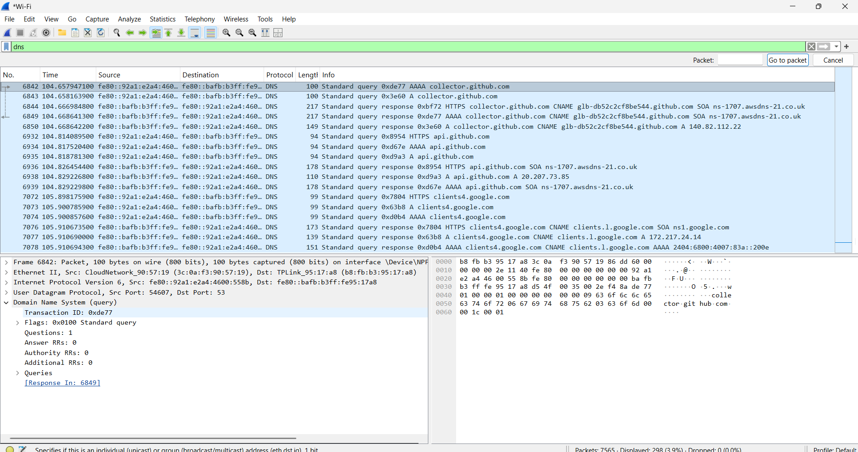
Figure 5 — DNS query packet (No. 6842) expanded, Transaction ID 0xde77, linked to its response in packet 6849
A second, related query (packet 6843, Transaction ID 0x3e60) was sent immediately after — this is normal: browsers/OS commonly send both an AAAA (IPv6) and an A (IPv4) query for the same hostname in parallel, which is exactly what happened here for collector.github.com.
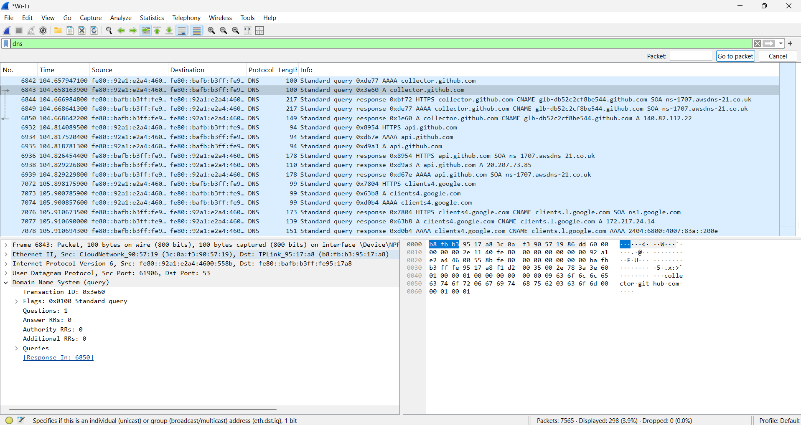
Figure 6 — Second parallel DNS query (No. 6843) for the same hostname, Transaction ID 0x3e60

3.2 The Response
Wireshark's "[Response In: 6849]" link points to the answer packet. Looking at a response of the same type elsewhere in the capture (packet No. 7078, a AAAA response for clients4.google.com) shows the structure every DNS response follows: the same Transaction ID as the matching query (so the client can pair them up), the Domain Name System (response) layer expanded to show Answer RRs greater than zero, and the actual resolved record — in this case a CNAME (clients.l.google.com) followed by the AAAA IPv6 address 2404:6800:4007:83a::200e.
Figure 7 — Example DNS response structure (packet No. 7078) showing the resolved CNAME and AAAA address
Applied to my chosen exchange: the response to packet 6842 (Transaction ID 0xde77) would carry the resolved AAAA record for collector.github.com back to my machine over the same UDP port 53, using the exact same query-response pairing mechanism shown above.

4. What I Learned
- DNS resolution happens in the clear (plaintext UDP on port 53) — anyone capturing traffic on the same network can see exactly which hostnames a device is looking up, even though the content of the website itself may be encrypted afterward.
- Modern browsing generates two parallel DNS queries per hostname (A and AAAA) rather than one, which I hadn't realized until I saw it directly in the capture.
- TLS and QUIC both hide the actual page content as opaque "Application Data" — I could see who my device was talking to and how much data was exchanged, but not what was inside, confirming the encryption is working as intended.
- TCP's three-way handshake (SYN, SYN-ACK, ACK) happens once per new connection, and a single page load can open many of these — I saw multiple separate handshakes for separate services within seconds.
- ARP only ever resolves addresses within the local network segment, never to remote/internet hosts — a useful reminder of where the boundary between "local" and "routed" traffic sits.
- Nothing genuinely sensitive (passwords, page content) appeared unencrypted in my capture, since almost everything I generated was HTTPS/TLS — the only plaintext information visible was metadata: which hostnames were being looked up (DNS) and which local device had which MAC address (ARP).

5. Actionable Findings & Recommendations
Based on what the capture actually showed, here are concrete, practical steps that would reduce the exposure observed above:

5.1 Plaintext DNS metadata exposure
Finding: every hostname I visited (collector.github.com, api.github.com, clients4.google.com, etc.) was visible in plaintext to anyone capturing traffic on the same network, since standard DNS runs unencrypted over UDP port 53.
- Fix: enable DNS-over-HTTPS (DoH) or DNS-over-TLS (DoT) at the OS or browser level (e.g. Windows 11 built-in encrypted DNS, or a resolver like Cloudflare 1.1.1.1/NextDNS that supports DoH). This encrypts the query itself, not just the page content afterward.
- Fix: on a network I control, run a local encrypted resolver (e.g. a DoH proxy) so all devices benefit without per-device configuration.

5.2 ARP has no authentication
Finding: ARP requests/replies (e.g. "Who has 192.168.0.3? Tell 192.168.0.1") are accepted at face value with no verification — this is the mechanism abused in ARP spoofing/poisoning attacks to intercept local traffic.
- Fix: on sensitive networks, enable Dynamic ARP Inspection (DAI) on managed switches, or use static ARP entries for critical hosts.
- Fix: run an ARP-spoofing detection tool (e.g. arpwatch or XArp) to alert on unexpected MAC/IP pairing changes.

5.3 Confirming encryption is actually in place
Finding: the TLS/QUIC traffic I captured showed only "Application Data" with no readable content, which is the expected, correct behaviour — but it's also exactly what a downgrade or misconfiguration would look like if only inspected superficially.
- Fix (practical habit): when auditing a service, explicitly check the negotiated TLS version and cipher suite in the handshake (visible in the Client/Server Hello before encryption starts) rather than assuming "TLS" in the protocol column means it's using a modern, secure version.
- Fix: prefer/enforce TLS 1.3 where possible, since it removes several legacy cipher weaknesses present in TLS 1.2.

5.4 Unnecessary protocol/port exposure
Finding: many parallel TCP connections (and their handshakes) were opened in a short window across multiple destination IPs — normal for browsing, but the same pattern is worth monitoring on servers, where an unexpectedly high rate of new SYNs from varied sources can indicate scanning or a SYN-flood attempt.
- Fix: on servers/production systems, use a firewall (e.g. Windows Defender Firewall, iptables) to explicitly allow only required inbound ports, and enable SYN-flood protections (SYN cookies) where available.
- Fix: baseline normal connection-rate patterns so anomalies stand out during monitoring.

